# CBSE PRACTICAL

**Computer Science (083)**

**SET 1**

**CODE FOR QUESTION 1:**

#include<iostream.h>

#include<fstream.h>

#include<stdio.h>

#include<conio.h>

#include<process.h>

class Computers

{

public:

int model_no;

char model_name[20];

void input()

{

cout<<"Enter the Model Number : ";

cin>>model_no;

cout<<"Enter the Model_name : ";

gets(model_name);

}

void display()

{

cout<<"The Model Number is "<<model_no<<endl;

cout<<"The Model Name is ";

puts(model_name);

cout<<endl;

}

};

void main()

{

clrscr();

int choice, M_no, flag=0;

char ans;

fstream f;

Computers C;

start:

cout<<"Main Menu!"<<endl;

cout<<"1. Append records in the file"<<endl;

cout<<"2. Search record using Model Number"<<endl;

cout<<"3. Display all the records"<<endl;

cout<<"4. Exit"<<endl;

cin>>choice;

switch(choice)

{

case 1: {

f.open("COMPRECORDS.dat",ios::app);

do

{

C.input();

f.write((char*)&C, sizeof(C));

cout<<"Do you want to continue? ";

cin>>ans;

}while(ans=='y'||ans=='Y');

f.close();

clrscr();

}

goto start;

case 2:{

f.open("COMPRECORDS.dat",ios::in);

cout<<"Enter the Model Number you want to search for : ";

cin>>M_no;

f.read((char*)&C, sizeof(C));

while(f)

{

if(C.model_no==M_no)

{

C.display();

flag=1;

break;

}

else

f.read((char*)&C, sizeof(C));

}

if(flag!=1)

cout<<"Record not found!";

f.close();

getch();

clrscr();

}

goto start;

case 3:{

f.open("COMPRECORDS.dat",ios::in);

f.read((char*)&C, sizeof(C));

while(f)

{

C.display();

f.read((char*)&C, sizeof(C));

}

f.close();

getch();

clrscr();

}

goto start;

case 4:{

cout<<"Press any key to exit!";

getch();

exit(0);

}

}

getch();

}

**OUTPUT FOR QUESTION 1:**

1. Main Menu of the program - 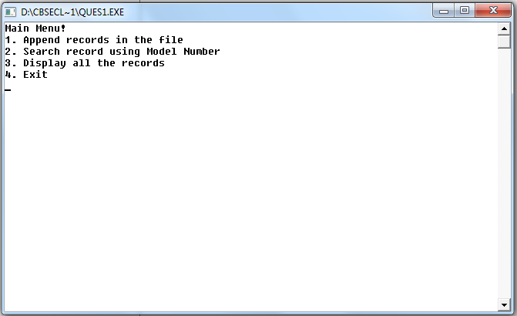
2. On pressing 1(Append record) -

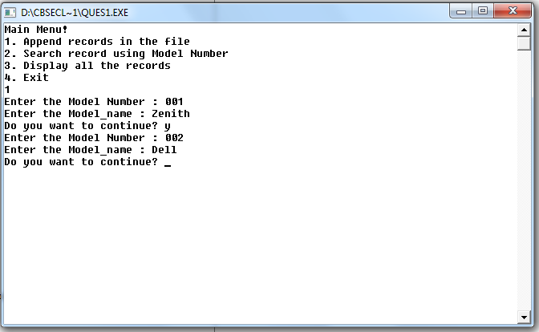

1. On pressing 2 (search record) -

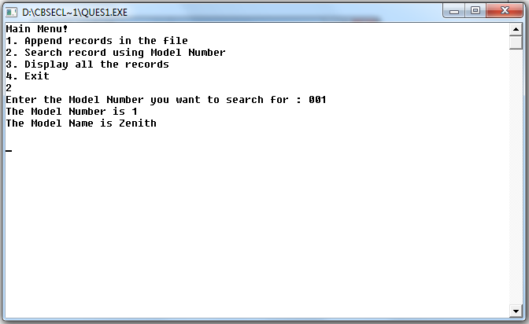

1. On pressing 3 (Display all record) –

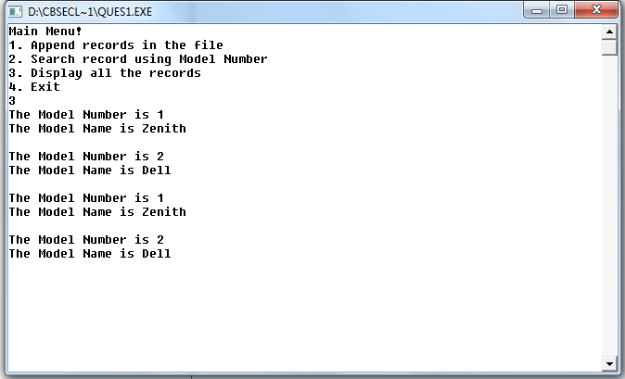

1. On pressing 2 (Record not found) –

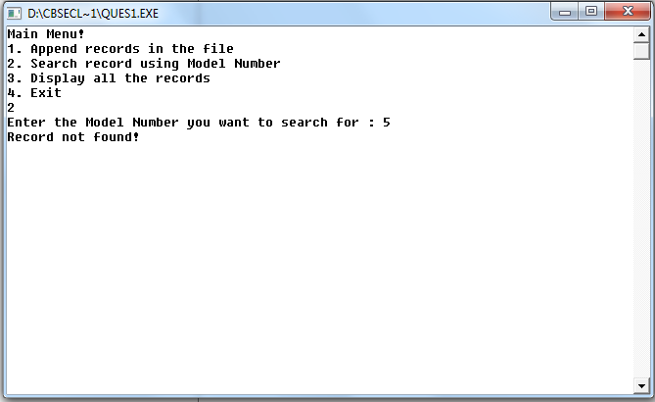

1. On pressing 4 (Exit) –

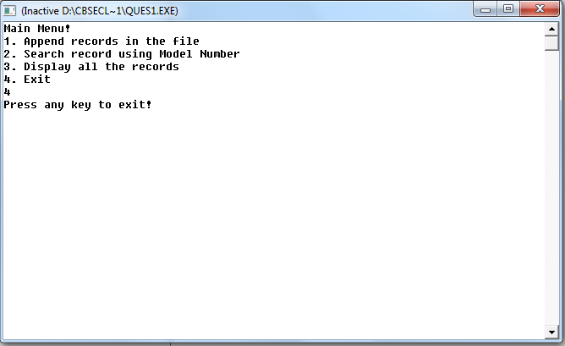

**QUESTION 2 :**

* To create table FLIGHTS :

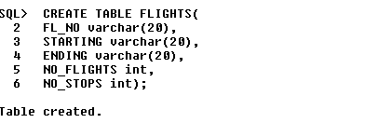

* To create table FARES :

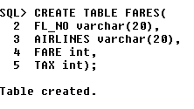

* To insert values in table FLIGHTS and table FARES :

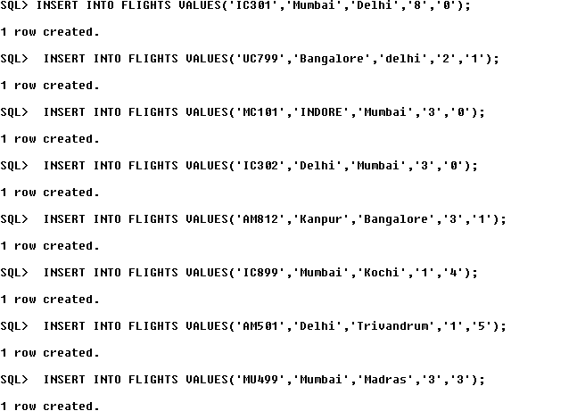

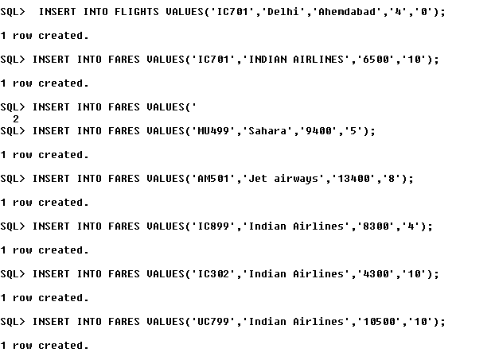

1. To display total number of flights starting from DELHI :

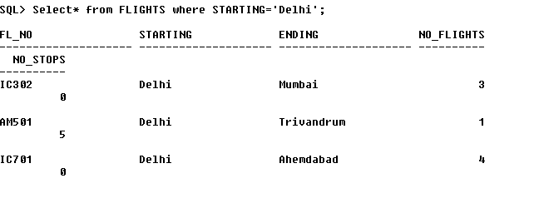

1. To display Flight details sorted by FL_NO whose starting or ending point is MUMBAI :

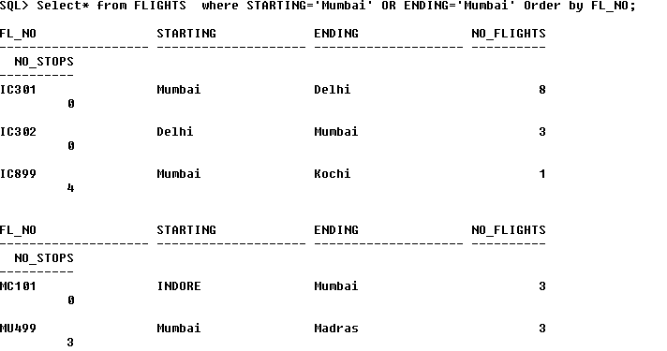

(iii)

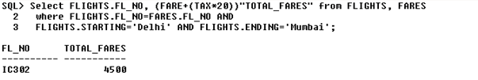

1. To display the minimum fare of each Airlines from the table FARES :

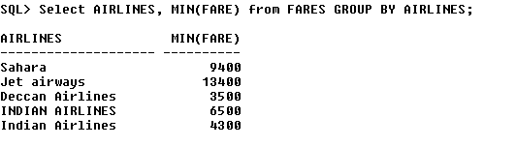

1. To display airlines, starting and ending whose fare is greater than 10000 :

